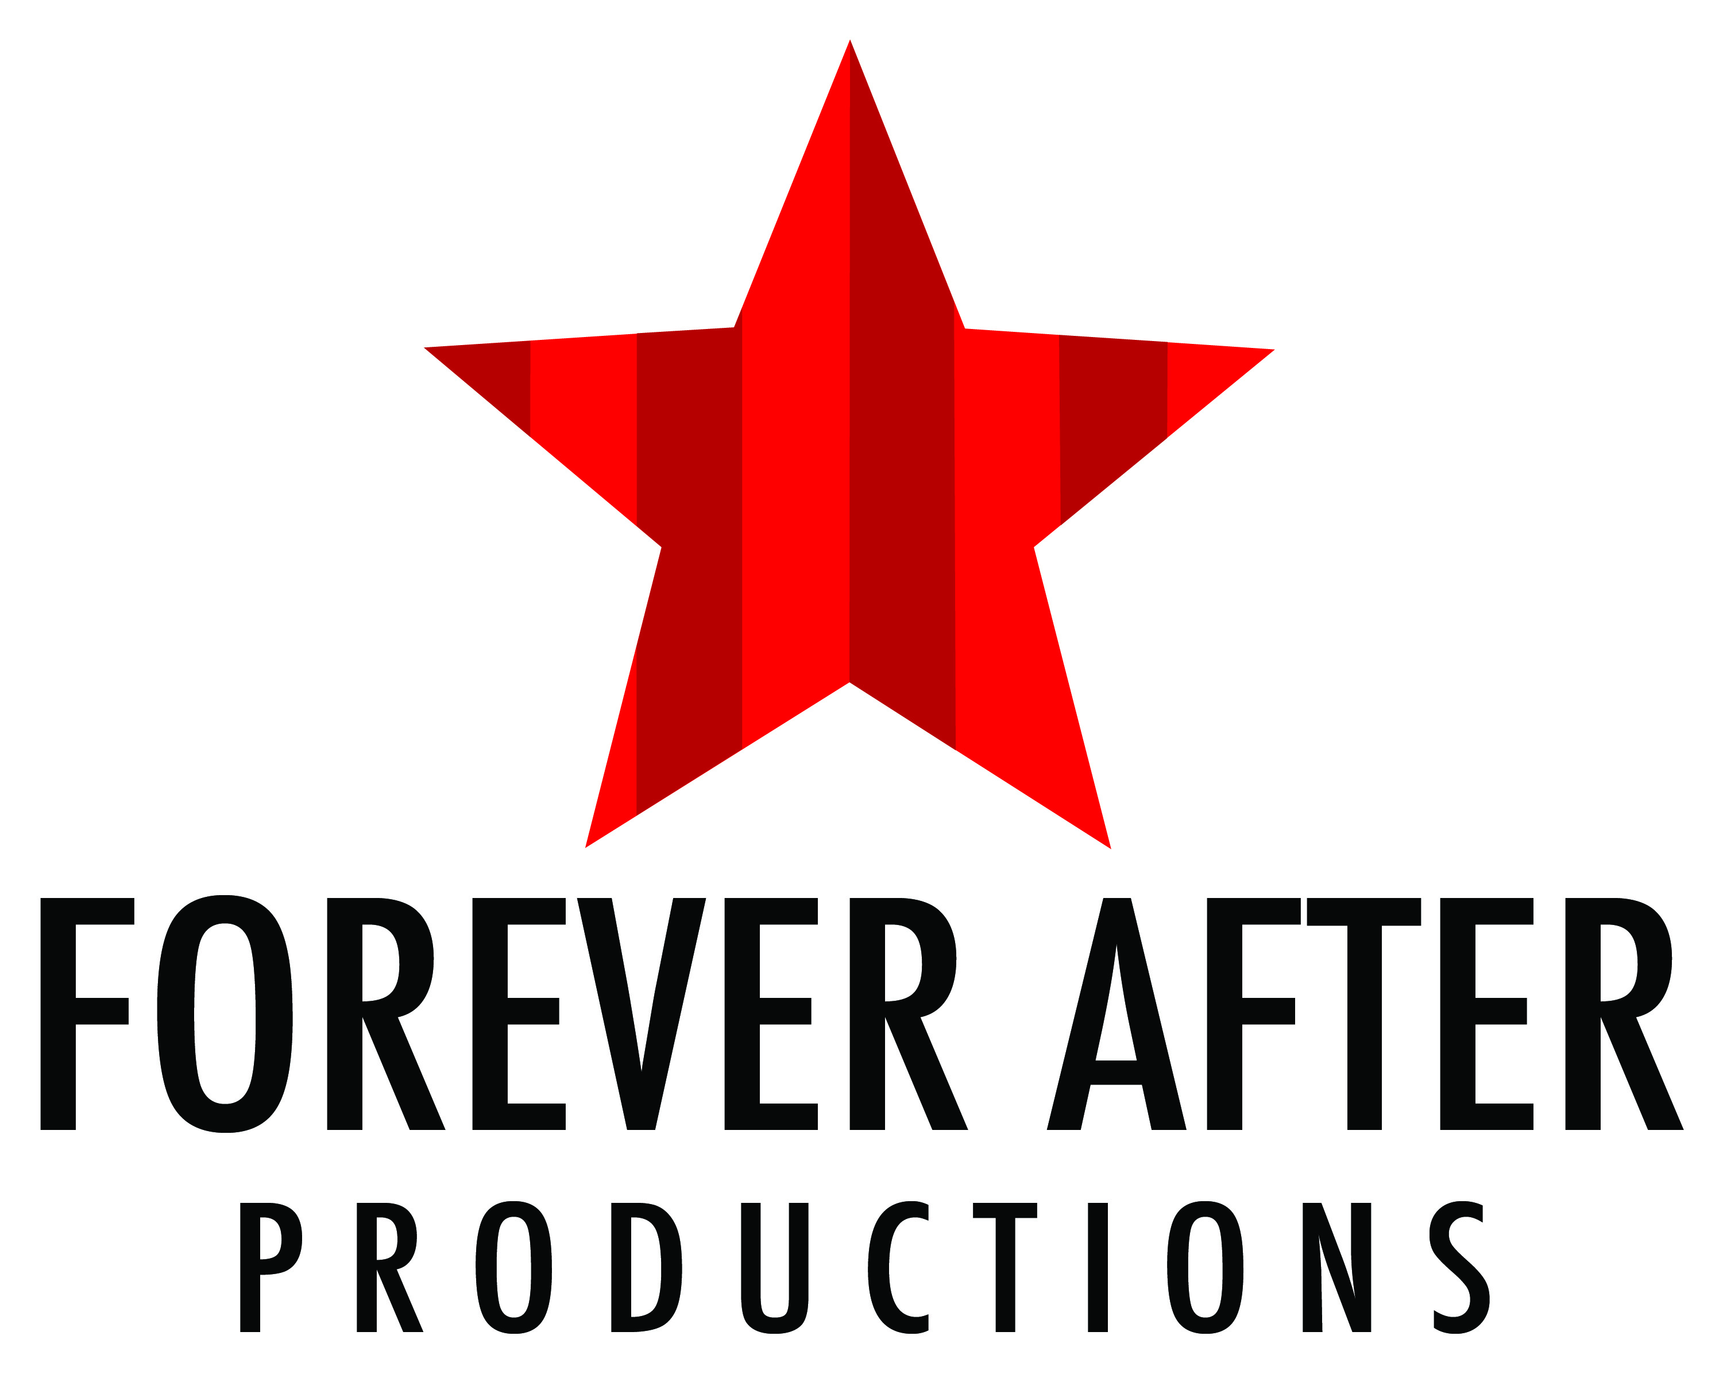
2018/2019 Theater Classes

PARTICIPANT INFORMATION, WAIVER OF LIABILITY, AND REGISTRATION FORM

Please write clearly.

Student’s Last Name, First Name: ____________________________________________
Date of Birth: _____________________
Parent/Guardian Name: ________________________________________________________
Street Address: ___________________________________________________
City: _____________________________
Phone Number: _______________________________
Parent Email __________________________________________

First Contact In Case of Emergency:
Name: ___________________________________________________________
Relation: _________________________
Street Address: ___________________________________________________
City: _____________________________
Phone Numbers: (H) _________________________/(C) _______________________

Second Contact In Case of Emergency (MUST BE DIFFERENT than parent/guardian):
Name: ______________________________________________________________
Relation: _________________________
Street Address: _______________________________________________________
City: _____________________________
Phone Numbers: (H) _________________________ / (C) ______________________

Please list all persons with permission to drop off/pick up your child, all persons must be 18 years or older.
Name: ___________________________________ Age: ______________
Relation: _________________________

Name: ___________________________________ Age: ______________
Relation: _________________________

HEALTH INFORMATION:
- Does your child have any existing health problems that we should know about? YES / NO
- Please list health problems.
____________________________________________________________________________________
2. Any physical restrictions? YES / NO
Please list restrictions.
____________________________________________________________________________________
3. Does your child take any medication during Program hours? YES / NO
Please list medication(s).

Note: Forever After Productions Staff are not authorized to dispense medications or administer injections.
Is there any additional information you would like to tell us about in regards to your child’s needs?

FALL SEASON BEGINS – SEPTEMBER 15th 2018
WINTER SEASON BEGINS – TBA
SPRING SEASON BEGINS – TBA

ALL CLASSES ARE SATURDAYS AND RUN 8 WEEKS.

Please mark with X which class you are signing up for:

PREMIER ACTING FOR AGES 3-5 YRS 10 - 10.30AM $65 FALL ___ WINTER ___ SPRING ___

OVATION ACTING FOR AGES 6-9 YRS 10.30 – 11.30 AM $85 FALL ___ WINTER ___ SPRING ___

ENCORE ACTING FOR AGES 10-14 YRS 11.30 – 12.30PM $85 FALL ___ WINTER ___ SPRING ___

Forever After Productions Office Number: 734-547-5156
Forever After Productions Office Email: foreveraftermail@gmail.com

Payment is required with the return of this form. We accept cash or check. NO refunds. Please make checks
payable to “Forever After Productions” and mail with this form to:

Theater Classes
Forever After Productions
Studio #107
650 Church Street
Plymouth
MI 48170

All classes are held at the above address.

WAIVER OF LIABILITY

I hereby state that the above participant is in good health and free from any communicable disease or illness & I shall defend, indemnify and hold harmless Forever After Productions and the officers and employees of Forever After Productions, from and against any damage, loss, theft, or destruction of any kind, and against any losses, liabilities, damages, injuries, claims, demands, costs and expenses of every kind and nature whether or not covered by insurance, including legal fees and disbursements arising out of and in connection with my or my child’s negligent use of the premises or the breach of any representation, warranty, or covenant contained herein. If Forever After Productions personnel are unable to reach an emergency contact listed herein, I hereby authorize them to secure emergency medical treatment as necessary. I agree to pay for all expenses that possibly may be incurred by this emergency case. In consideration of Forever After Productions permitting my child to participate in said events, I hereby for myself, my child, my heirs, administration and assigns, waive and release any and all rights and claims for damages I may have against Forever After Productions, its personnel and any other organizations connected with this event, their successors, and assigns, and for any and all injuries which I or my child may suffer while taking part in any activities connected with this event. In case of injury, and an emergency contact is unable to be contacted by your staff, I give my consent to have medical treatment administered to me or my child if deemed necessary by a physician. My signature allows permission to use photographs and/or videos of my child to be used in association with advertising Forever After Productions or its programming.

MY CHILD HAS PERMISSION TO:
For kids 14 years and older:

Sign him/herself in and out. YES / NO

Note: Forever After Productions will not supervise your child before they sign in or after they sign out. This privilege will be revoked should a child neglect to sign-in or sign-out on any occasion.

Please note that it is your responsibility to inform us of any changes in your child’s health status.

Parent/Guardian Signature: _______________________________

Date: ____________________

