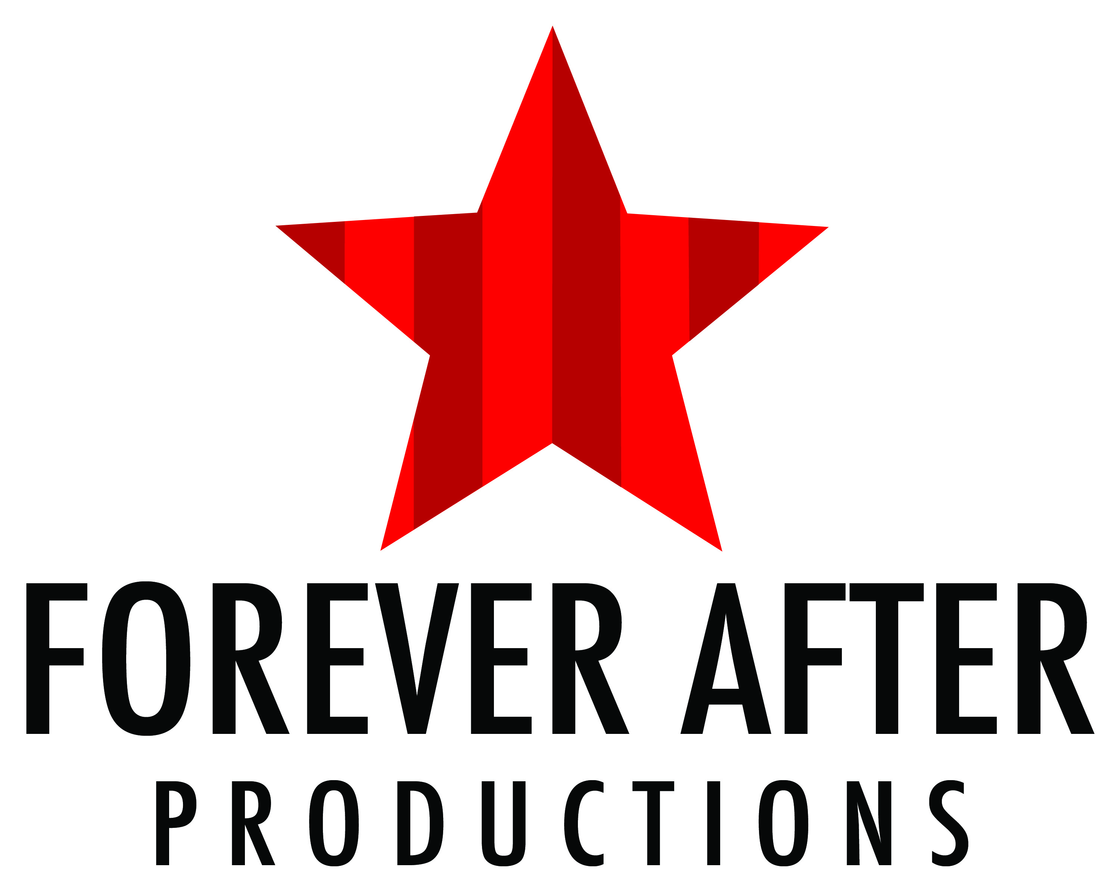
Forever After Productions
Costume Rental Agreement.

All rentals are secondary to Forever After Productions. Since rentals are not our primary business, there may be some limitations on when and what costumes are available at the time of your rental.

Rental Start Date: _____________ Rental Return Date:_____________
Contact Name:____________________________________
Phone number:_____________
Organization:______________________________________________________ Address:_________________________________________________________________________ City:________________________________________ State____ Zip ________
Production Name: _________________________________________________________________
Production Open Date:_____________________ Production Close Date:____________________

Costume Rental Polices:
Costumes may be altered to fit only using pins – no sewing. If a costume is returned in an altered condition, damages fees will be charged.
Costumes may NOT be cut, dyed, painted or permanently altered without written permission from Forever After Productions. Tape, iron-on bonding web, glue or any other type of adhesives may NOT be used on any costumes.
If the rental time exceeds the agreed upon rental period, a charge of 20% of the total rental will be added for each additional week.
Damaged or Lost Costume Fees: Normal wear and tear on costumes is expected and won't incur extra charges. Damage beyond normal wear and tear will incur damage charges. Damage charges will be assessed for broken zippers, detached garment pieces, make-up or other permanent stains or any other damage that renders the costume from being re-used. It also includes the cost of the supplies needed to restore the garment to its original state as well as labor costs.
Major damage to costumes, including irreparable tears, or irreversible marks will be assessed at the replacement value of the costume.
Lost costumes will be assessed with a Lost Costume Fee equal to the replacement cost of the costume.
Return Rental Date:
The return date is calculated by your production closing date plus 7 calendar days. Costumes must be cleaned prior to return date. Garments must be returned in the same condition as received.
Payment:
Payment is to be made in full at time of rental by cash or check only. No items are to be removed from Forever After Productions without prior payment. There will be NO REFUNDS for any items.

Disclaimers:
Costumes are sent in the best possible condition; however, costumes are used and may have small imperfections that do not affect the integrity of the performance. The renter agrees to accept that Forever After Productions and its volunteers are not responsible for accidents or injuries related directly or indirectly from the use of the rented items.
___________________________________________________________________________________________
I have read and understand the Costume Rental Agreement above and agree to abide by them. I agree to payment damage/replacement to Forever After Productions.

Signature:___________________________ Date:______________
___________________________________________________________________________________________

ITEM DESCRIPTION | AMOUNT | PRICE

TOTAL DUE $________
DATE ITEMS RETURNED:____________

